1. **Install Power BI Desktop and share the final screenshot of the report view page which appears when power desktop starts.**

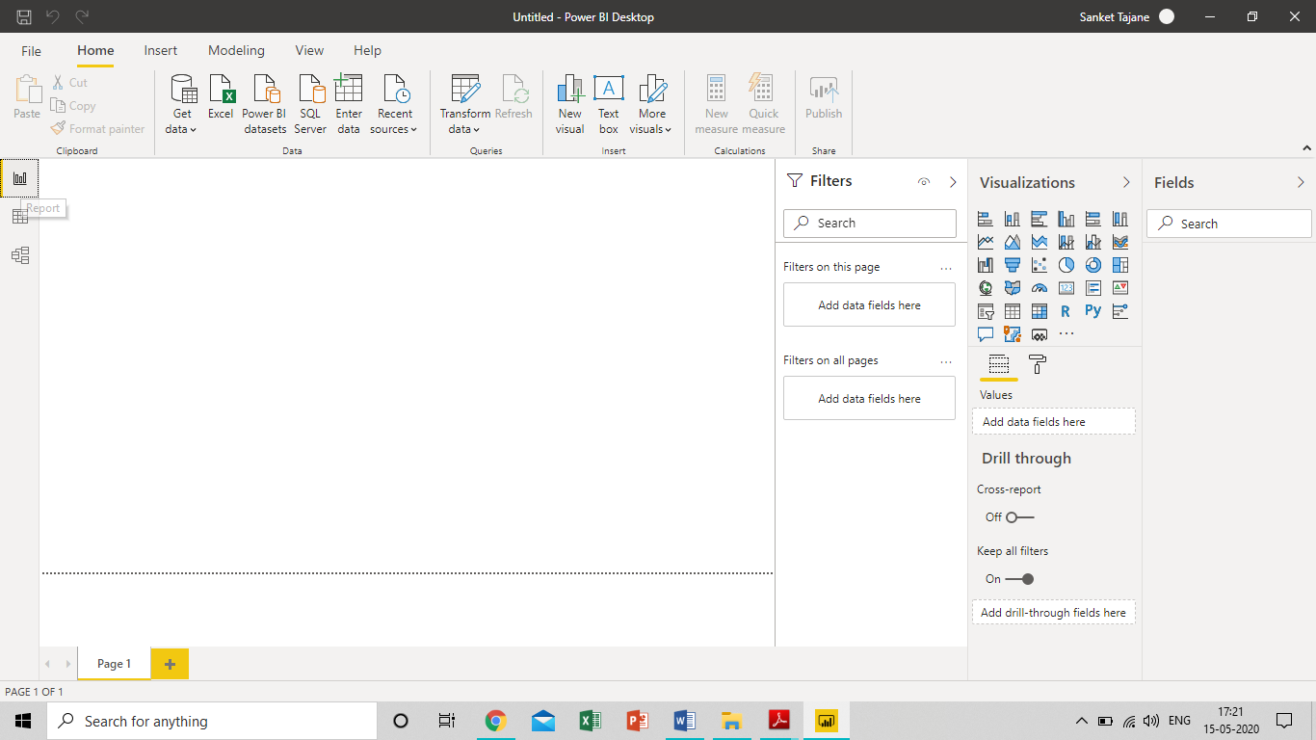

Fig. Screenshot of Report View

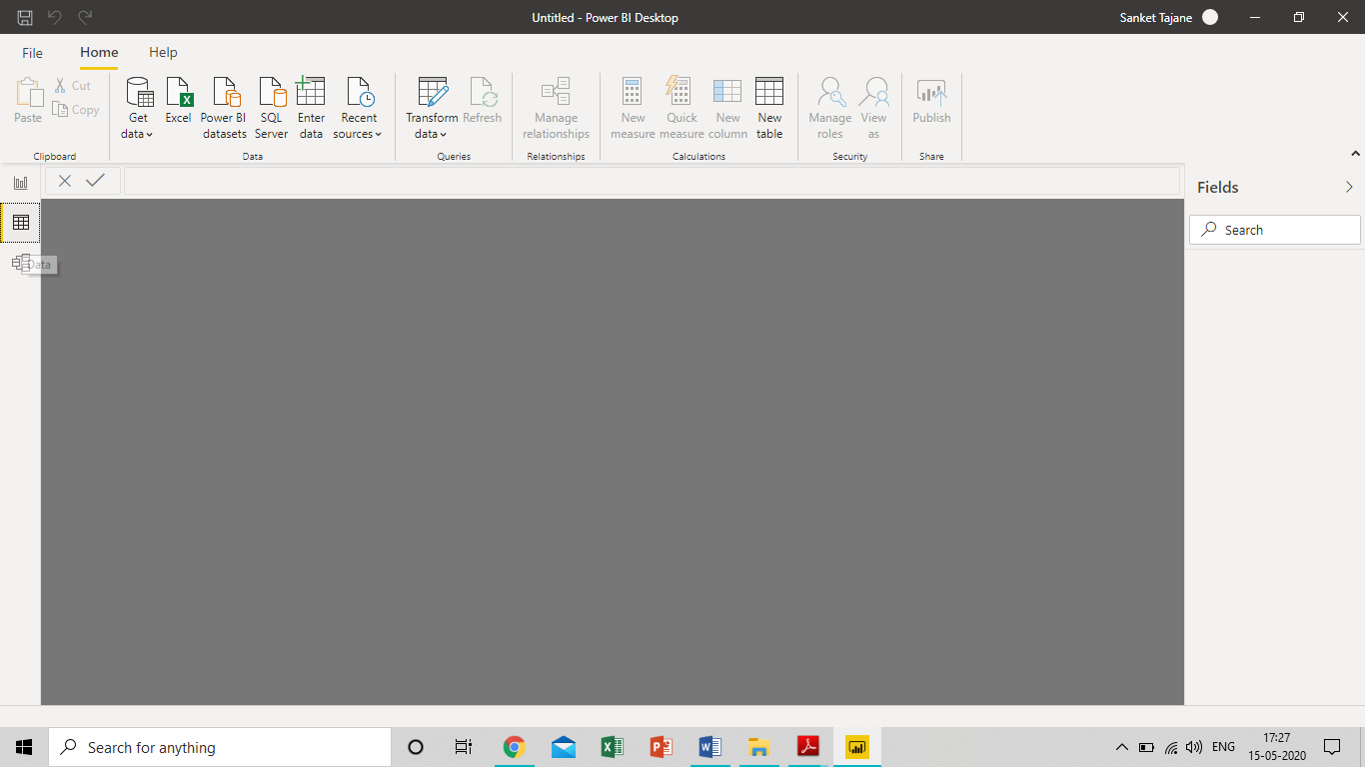

Fig. Screenshot of Data View

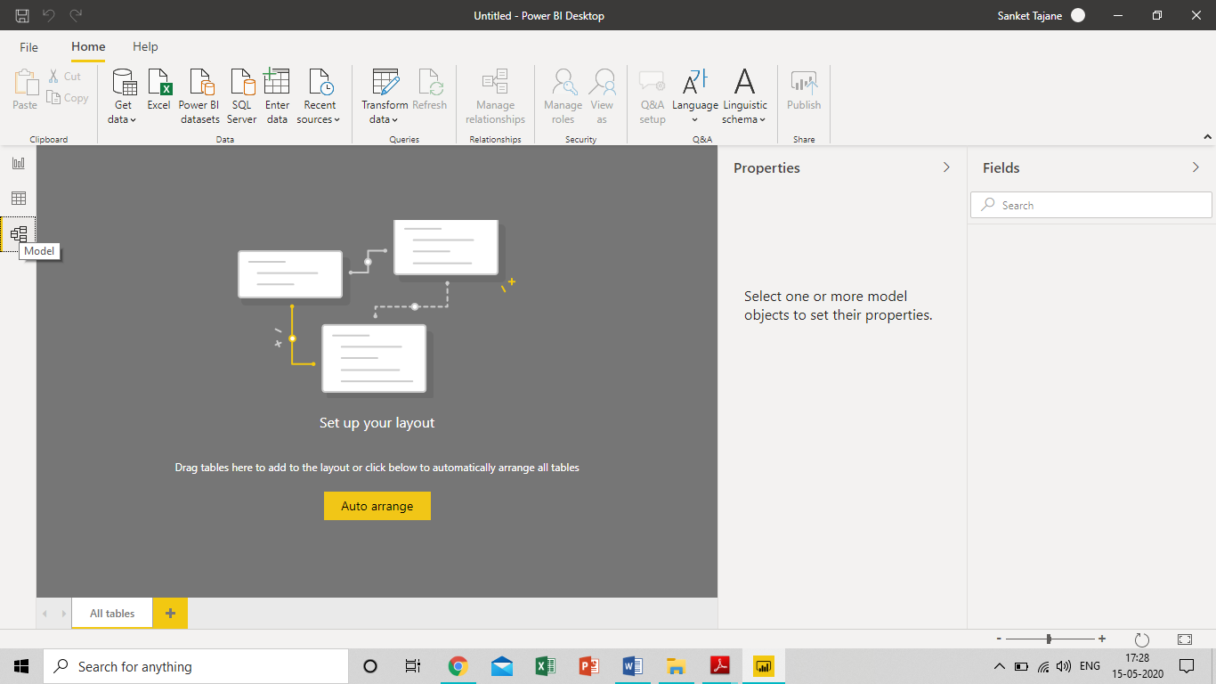

Fig. Screenshot of Model View

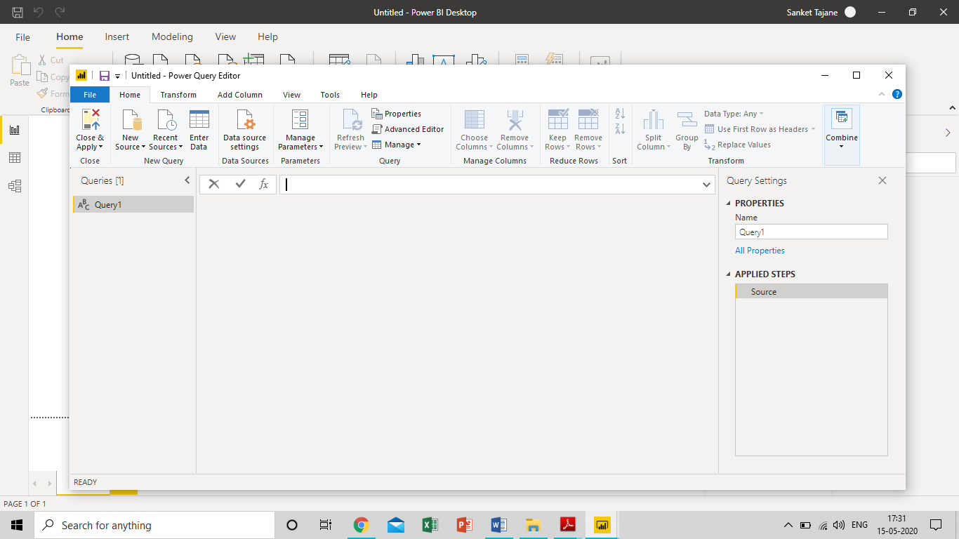

Fig. Screenshot of Power Query Editor

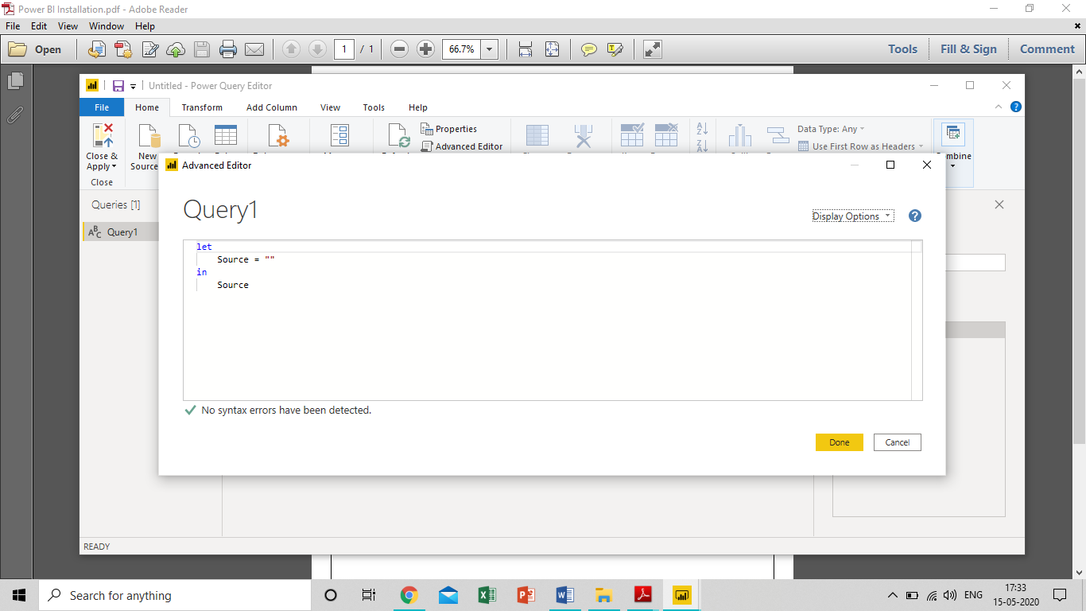

Fig. Screenshot of Advance Editor

1. **Prepare a document with details of the following along with their price**

− Power BI Desktop

− Power BI Pro

− Power BI Premium

1. **Power BI Desktop**: **Cost: Free**

Power BI Desktop is a free application you install on your local computer that lets you connect to, transform, and visualize your data. With Power BI Desktop, you can connect to multiple different sources of data, and combine them (often called modeling) into a data model. This data model lets you build visuals, and collections of visuals you can share as reports, with other people inside your organization. Most users who work on business intelligence projects use Power BI Desktop to create reports, and then use the Power BI service to share their reports with others.

The most common uses for Power BI Desktop are as follows:

* Connect to data
* Transform and clean that data, to create a data model
* Create visuals, such as charts or graphs, that provide visual representations of the data
* Create reports that are collections of visuals, on one or more report pages
* Share reports with others by using the Power BI service

People most often responsible for such tasks are often considered *data analysts* (sometimes referred to as *analysts*) or business intelligence professionals (often referred to as *report creators*). However, many people who don't consider themselves an analyst or a report creator use Power BI Desktop to create compelling reports, or to pull data from various sources and build data models, which they can share with their coworkers and organizations.

There are three views available in Power BI Desktop, which you select on the left side of the canvas. The views, shown in the order they appear, are as follows:

* **Report**: In this view, you create reports and visuals, where most of your creation time is spent.
* **Data**: In this view, you see the tables, measures, and other data used in the data model associated with your report, and transform the data for best use in the report's model.
* **Model**: In this view, you see and manage the relationships among tables in your data model.

1. **Power Bi Pro: Cost: 9.99/user/month**

Power BI Pro is the full version of Power BI, complete with the ability to use Power BI for both building dashboards and reports and unlimited viewing, sharing and consumption of your created reports (and reports shared by others) - the latter not possible with Power BI Desktop.

A breakdown of Power BI Pro’s differences against Power BI Desktop:

* Ability to embed Power BI visuals into apps (PowerApps, SharePoint, Teams, etc)
* Native integration with other Microsoft solutions (Azure Data Services)
* Share datasets, dashboards and reports with other Power BI Pro users
* Can create App Workspaces and peer-to-peer sharing

Power BI Pro is licensed by individual user. For example, if your organisation has 20 people that need to full capabilities of self-service BI to create dashboards and reports, you need 20 licenses of Power BI Pro, which gives these users full access to creation of reports and unlimited consumption (viewing) of any created content.

If you have a lot of users, Power BI Pro can obviously become quite expensive - but there’s a better option if you have more users that need to consume reports than use Power BI for creating reports, which we detail below.

1. **Power Bi Premium: Cost: $4995/month**

Power BI Premium is the most expensive tier of Power BI currently available and very distinct from the other two versions available on the market.

On top of the features and functionality standard to all versions of the service, users of Power BI Premium get:

* Increased data capacity limits and maximum performance
* Access to one API surface
* Ability to embed Power BI visuals into apps (PowerApps, SharePoint, Teams, etc)
* Larger storage sizes for extended deployments
* Geo distribution, higher refresh rates, isolation, pin to memory, read-only replicas
* Power BI Report Server

Power BI Premium differs from the free version and Power BI pro in its licensing model, which only suits a specific size and type of organisation and business scenario. You can purchase Premium in a range of capacity sizes that offer different numbers of memory and virtual cores that can scale as your data analysis requirements change.

With Power BI Premium, you are licensing capacity for your datasets, dashboards and reports, not just licensing all users of that content. In other words, you’re not buying individual licenses, you’re buying them in bulk to allow a large number of your users to use Power BI to view reports. All of your content is stored in Premium and can then be viewed by as many users in your organisation as you want, without additional per-user costs.